Online Payments Fraud Detection using Machine Learning

Project Description:
Online Payments Fraud Detection using Machine Learning is an intelligent security system designed to detect and prevent fraudulent activities in online financial transactions. With the rapid growth of digital payments, ensuring transaction security has become a critical challenge for financial institutions and e-commerce platforms.
This project leverages historical transaction data, customer behavior patterns, and advanced machine learning algorithms to identify suspicious activities in real time. By analyzing key transaction features such as transaction amount, account balances, transaction type, device information, and behavioral patterns, the system predicts whether a transaction is legitimate or fraudulent.
The primary objective of this system is to minimize financial losses, protect user accounts, and enhance trust in digital payment platforms by providing accurate and real-time fraud detection
.
Technical Architecture:

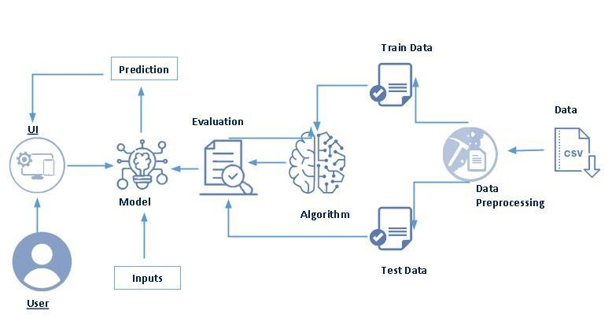

Pre-Requisites:

To complete this project, you will require the following software, concepts, and packages

Anaconda navigator:

Refer to the link below to download the anaconda navigator

Python packages:

Open anaconda prompt as administrator

Type “pip install numpy” and click enter.

Type “pip install pandas” and click enter.

Type “pip install scikit-learn” and click enter.

Type ”pip install matplotlib” and click enter.

Type ”pip install scipy” and click enter.

Type ”pip install pickle-mixin” and click enter.

Type ”pip install seaborn” and click enter.

Type “pip install Flask” and click enter.

Prior Knowledge :

You must have prior knowledge of following topics to complete this project.

1. Machine Learning Basics

You should understand:

Supervised Learning – Training a model using labeled data (Fraud or Safe).

Classification – Predicting whether a transaction is Fraud (1) or Safe (0).

Decision Tree – A model that makes decisions based on conditions.

Random Forest – A group of decision trees that improves accuracy.

KNN (K-Nearest Neighbor) – Classifies data based on similarity.

XGBoost – An advanced algorithm that gives high prediction accuracy.

2. Model Evaluation

You should know basic evaluation metrics such as:

Accuracy

Precision

Recall

F1-Score

Confusion Matrix

These help measure how well the fraud detection model works.

3. Python Programming

Basic knowledge of:

Variables and functions

Loops and conditions

Using libraries like:

Pandas

NumPy

Scikit-learn

4. Data Preprocessing

You should understand:

Cleaning data

Handling missing values

Splitting data into training and testing sets

5. Flask Basics (Web Development)

Basic understanding of:

Creating routes using @app.route()

Handling form input

Connecting ML model with frontend

Displaying prediction results

6. HTML & CSS Basics

Basic knowledge to create:

Input form page

Result page

Simple UI design

Project Objectives:

By the end of this project you will:

Know fundamental concepts and techniques used for machine learning.

Gain a broad understanding of data.

Have knowledge of pre-processing the data/transformation techniques and some visualization concepts before building the model

Learn how to build a machine learning model and tune it for better performance

Know how to evaluate the model and deploy it using flask

Project Flow:

- The user interacts with the UI to enter the input.
- Entered input is analyzed by the model which is integrated.
- The predictions made by the model are showcased on the UI
To accomplish this, we have to complete all the activities listed below,
- Data collection
  - Collect the dataset or create the dataset
- Data pre-processing
  - Removing unnecessary columns
  - Checking for null values
- Visualizing and analyzing data
- Univariate analysis
- Bivariate analysis
- Descriptive analysis
- Model building
  - Handling categorical values
  - Dividing data into train and test sets
  - Import the model building libraries
  - Comparing the accuracy of various models
  - Hyperparameter tuning of the selected model
  - Evaluating the performance of models
  - Save the model
- Application Building
  - Create an HTML file
  - Build python code

Project Structure:

Create the Project folder which contains files as shown below
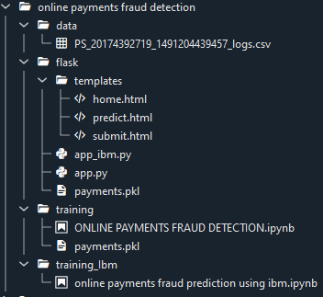
- We are building a flask application which needs HTML pages stored in the templates folder and a python script app.py for scripting.
- Model.pkl is our saved model. Further we will use this model for flask integration.
- Training folder contains model training files and the training_ibm folder contains IBM deployment file

Milestone 1: Data Collection
Machine Learning depends heavily on data. Dataset can be downloaded from open-source platforms or created manually.
Link:
https://www.kaggle.com/datasets/rupakroy/online-payments-fraud-detection-dataset

Milestone 2: Visualizing and Analyzing the Data

Activity 1: Importing Libraries
Required libraries such as NumPy, Pandas, XG boost and Matplotlib are imported for dataset
analysis.

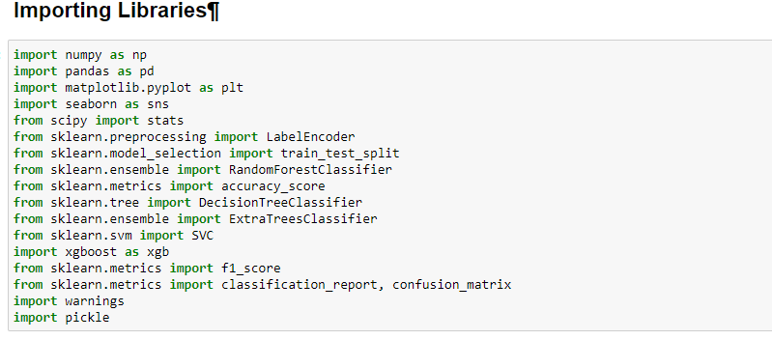

Activity 2: Reading the Dataset
Our dataset format might be in .csv, excel files, .txt, .json, etc. We can read the dataset with the help of pandas.
In pandas we have a function called read_csv() to read the dataset. As a parameter we have to give the directory of the csv file.
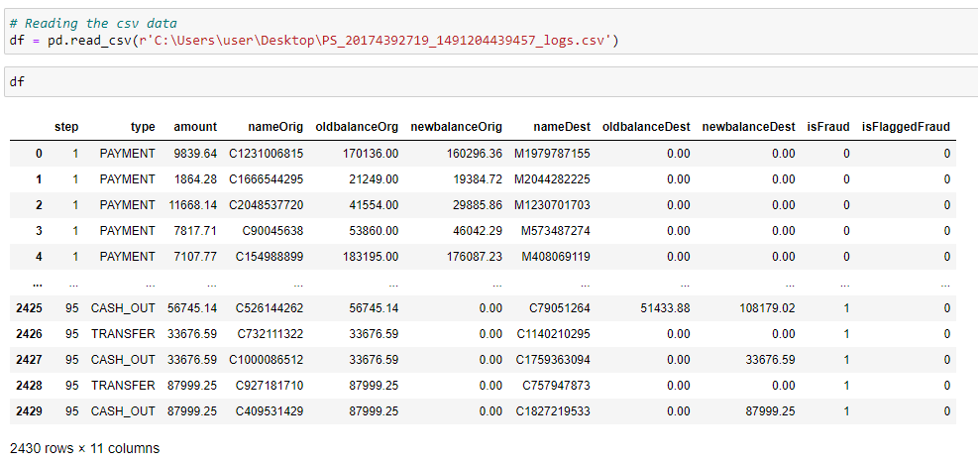

Activity 3: Dataset Analysis
- univariate analysis:

In simple words, univariate analysis is understanding the data with a single feature. Here I have displayed the graph such as histplot .

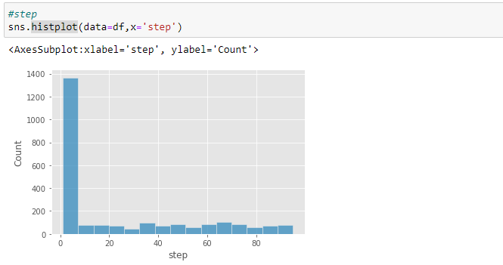

The distribution of one or more variables is represented by a histogram, a traditional visualisation tool, by counting the number of observations that fall within.

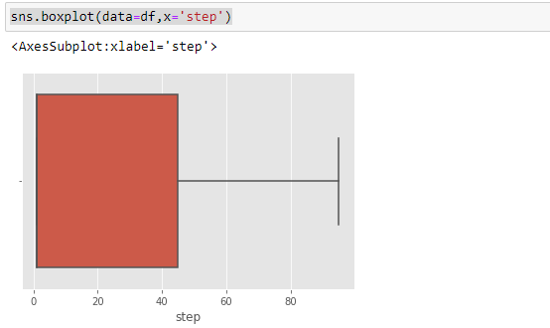

Here, the relationship between the step attribute and the boxplot is visualised.

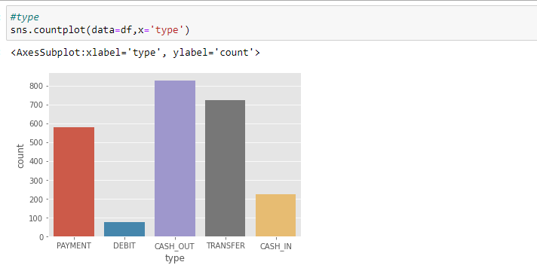

Here, the counts of observations in the type attribute of the dataset will be displayed using a countplot.

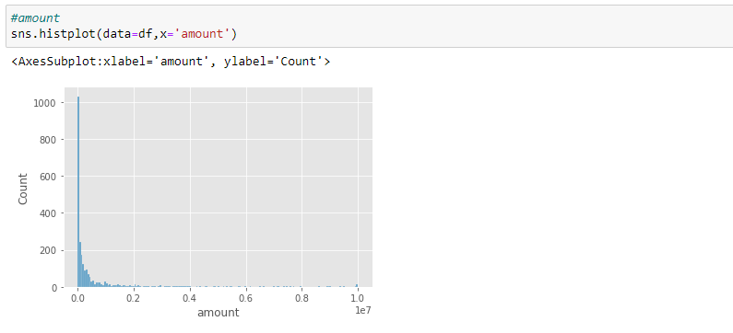

By creating bins along the data's range and then drawing bars to reflect the number of observations that fall within the amount attribute in the dataset.

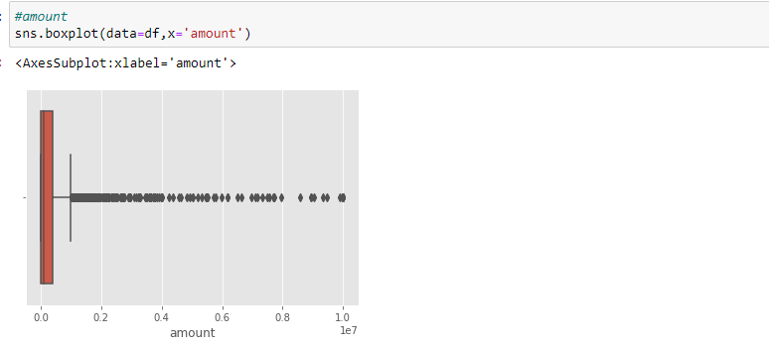

Here, the relationship between the amount attribute and the boxplot is visualised.

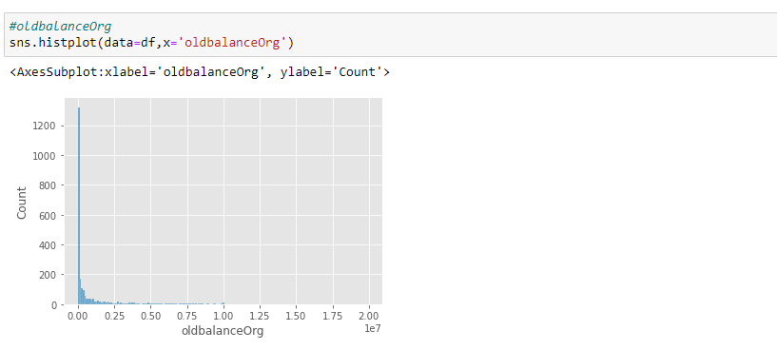

By creating bins along the data's range and then drawing bars to reflect the number of observations that fall within the oldbalanceOrg attribute in the dataset.

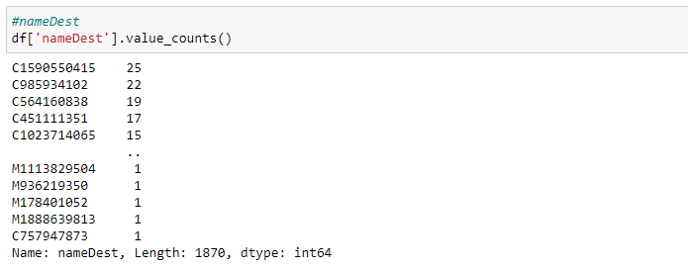

utilising the value counts() function here to determine how many times the nameDest column appears.

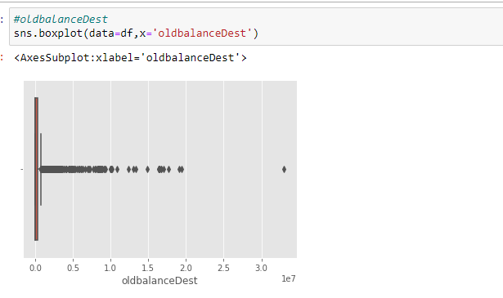

Here, the relationship between the oldbalanceDest attribute and the boxplot is visualised.

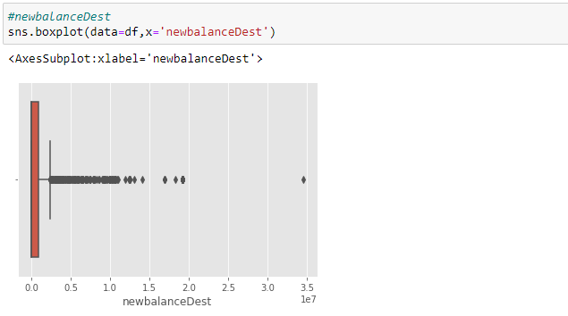

Here, the relationship between the newbalanceDest attribute and the boxplot is visualised.

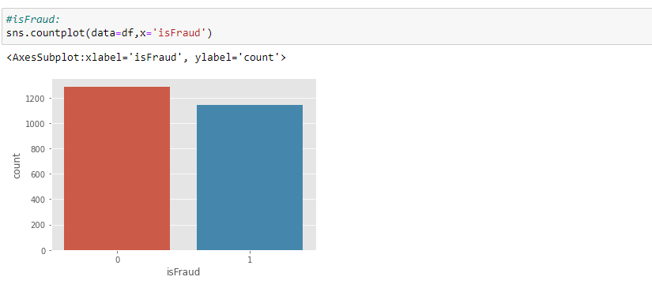

using the countplot approach here to count the number of instances in the dataset's target isFraud column.

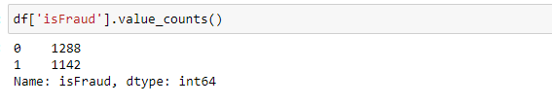

Here, we're using the value counts method to figure out how many classes there are in the dataset's target isFraud column.

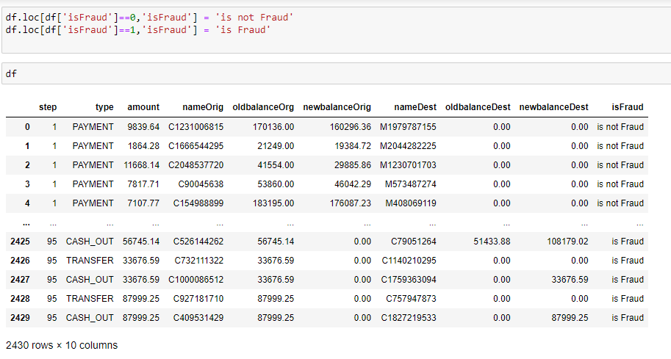

converting 0-means: is not fraud and 1-means: is fraud using the loc technique here

Descriptive analysis

Descriptive analysis is to study the basic features of data with the statistical process. Here pandas has a worthy function called describe. With this describe function we can understand the unique, top and frequent values of categorical features. And we can find mean, std, min, max and percentile values of continuous features

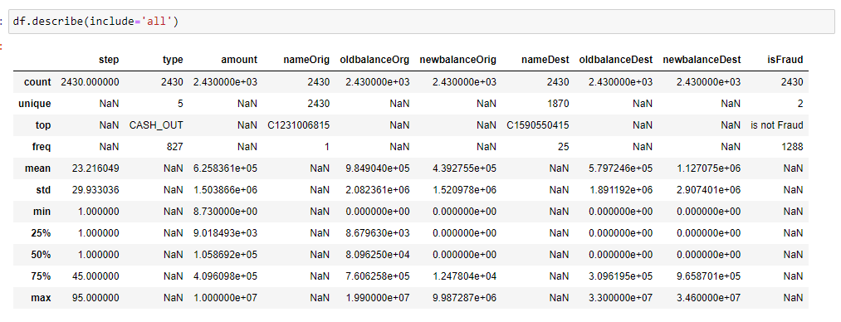

Milestone 3: Data Pre-processing
Collected dataset is cleaned before training the model.
Steps involved:
Handling Missing Values Handling Categorical Data Normalization
Feature Selection Splitting Dataset

Activity 1: Checking for Null Values
Isnull is used (). sum() to check your database for null values. Using the df.info() function, the data type can be determined.
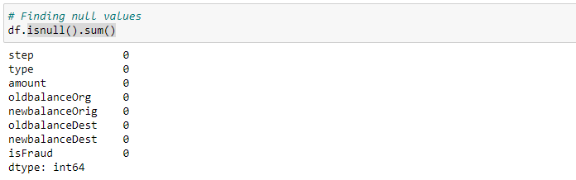
For checking the null values, data.isnull() function is used. To sum those null values we use the .sum() function to it. From the above image we found that there are no null values present in our dataset.So we can skip handling of missing values step.
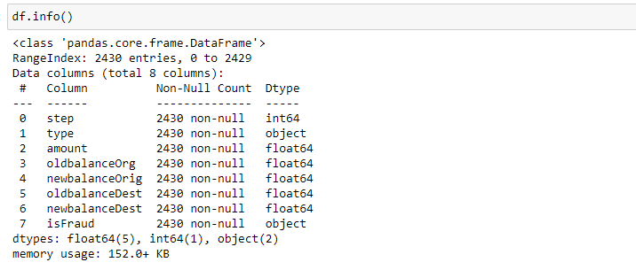
determining the types of each attribute in the dataset using the info() function

Activity 2: Handling outliers

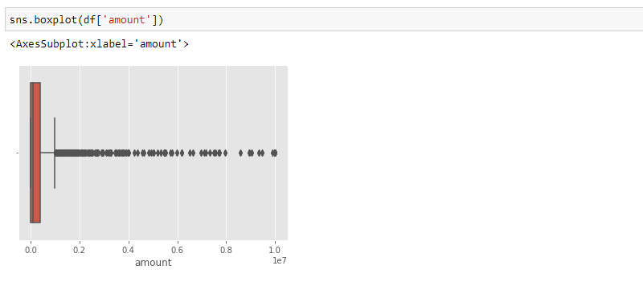

Here, a boxplot is used to identify outliers in the dataset's amount attribute.

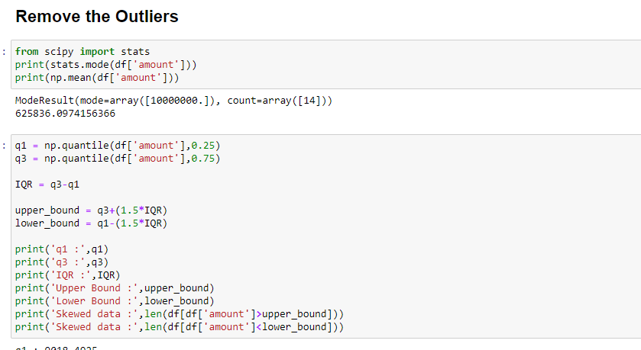

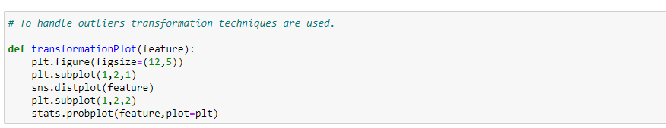

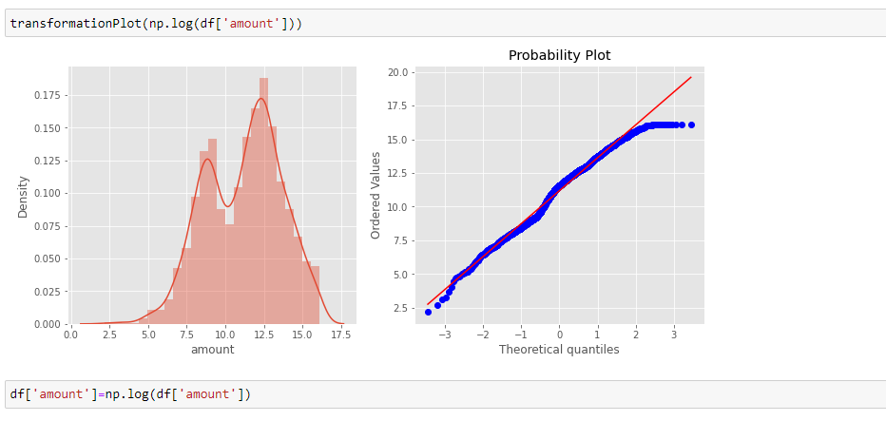

Here, transformationPlot is used to plot the dataset's outliers for the amount property.

Activity 3: Object data labelencoding

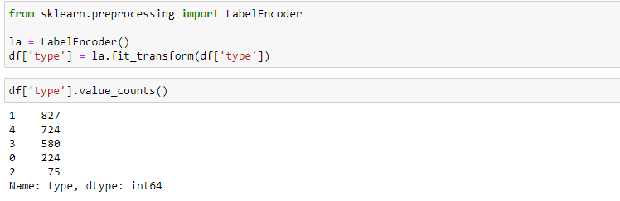

using labelencoder to encode the dataset's object type

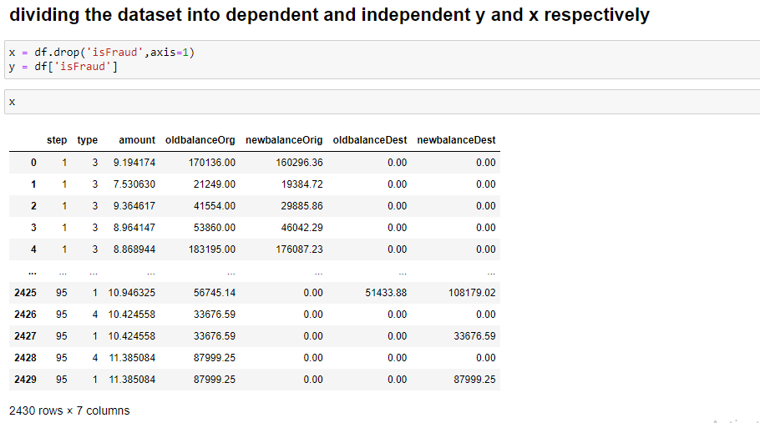

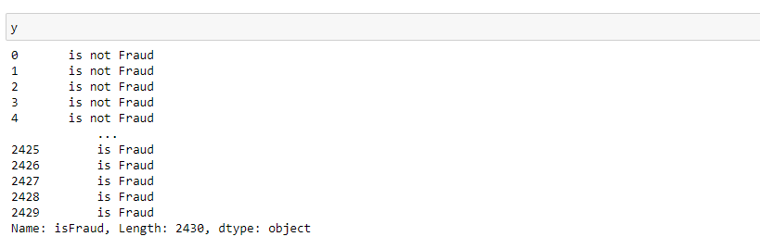

Training and Testing datasets are created:
80% Training Data
20% Testing Data

Activity 4: Splitting data into train and test

Now let’s split the Dataset into train and test setsChanges: first split the dataset into x and y and then split the data set.

Here x and y variables are created. On x variable, df is passed with dropping the target variable. And my target variable is passed. For splitting training and testing data we are using the train_test_split() function from sklearn. As parameters, we are passing x, y, test_size, random_state.

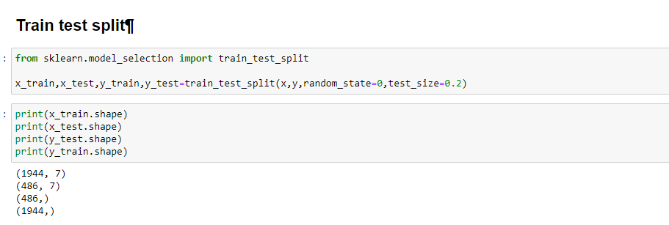

Milestone 4: Model Building
After preprocessing, the dataset is trained using Machine Learning models.
Steps involved:
Import Model Libraries Initialize Model
Train Model Test Model
Evaluate Performance
Activity 1: Random Forest classifier
A function named RandomForest is created and train and test data are passed as the parameters. Inside the function, the RandomForestClassifier algorithm is initialised and training data is passed to the model with the .fit() function. Test data is predicted with .predict() function and saved in a new variable. For evaluating the model, a confusion matrix and classification report is done.

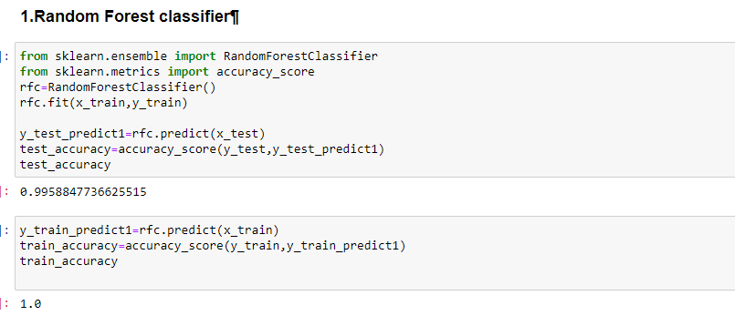
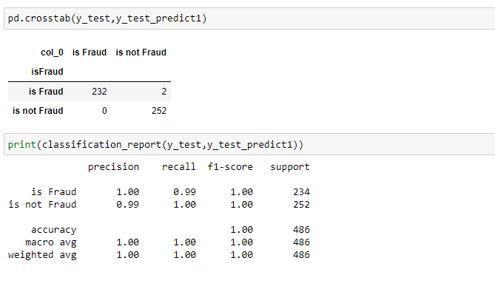
Activity 3: Decision tree Classifier
A function named Decisiontree is created and train and test data are passed as the parameters. Inside the function, the DecisiontreeClassifier algorithm is initialised and training data is passed to the model with the .fit() function. Test data is predicted with the .predict() function and saved in a new variable. For evaluating the model, a confusion matrix and classification report is done.
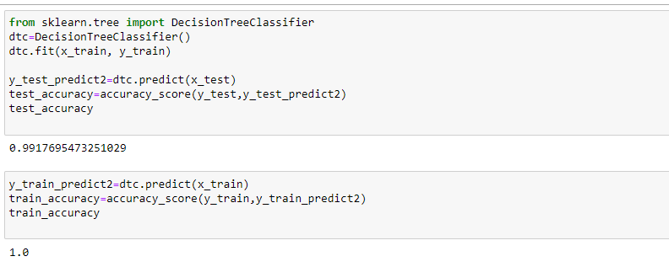
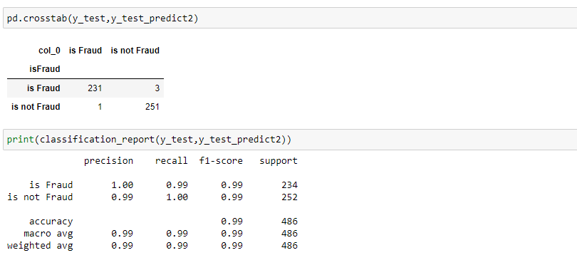
Activity 3: xgboost Classifier
A function named xgboost is created and train and test data are passed as the parameters. Inside the function, the xgboostClassifier algorithm is initialised and training data is passed to the model with the .fit() function. Test data is predicted with .predict() function and saved in a new variable. For evaluating the model, confusion matrix and classification report is done
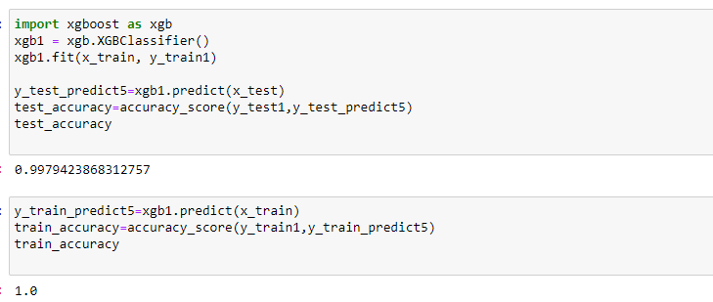

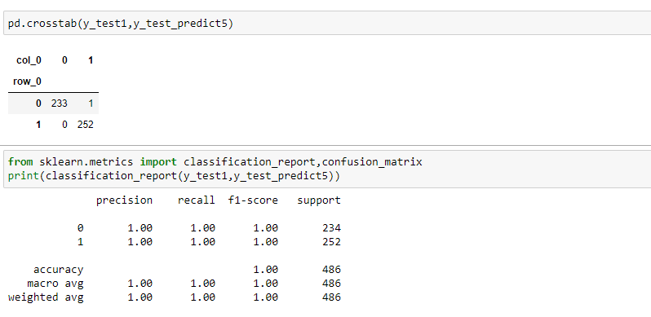

Evaluating performance of the model and saving the model :

From sklearn, accuracy_score is used to evaluate the score of the model. On the parameters, we have given svc (model name), x, y, cv (as 5 folds). Our model is performing well. So, we are saving the model is svc by pickle.dump().

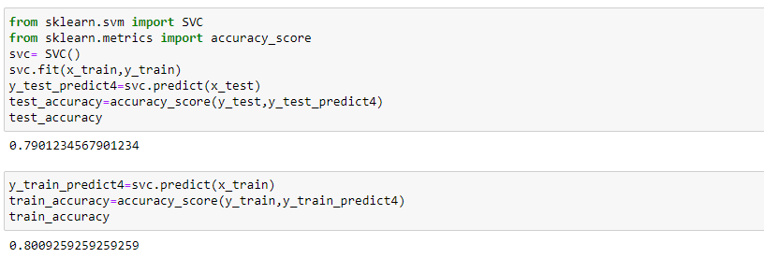

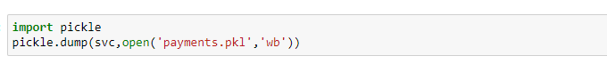

Milestone 5: Application Building
In this section, we will be building a web application that is integrated to the model we built. A UI is provided for the uses where he has to enter the values for predictions. The enter values are given to the saved model and prediction is showcased on the UI.
This section has the following tasks
- Building HTML Pages
- Building serverside script
Activity1: Building Html Pages:
For this project create three HTML files namely
- home.html
- predict.html
- submit.html
and save them in the templates folder.

Let’s see how our home.html page looks like:
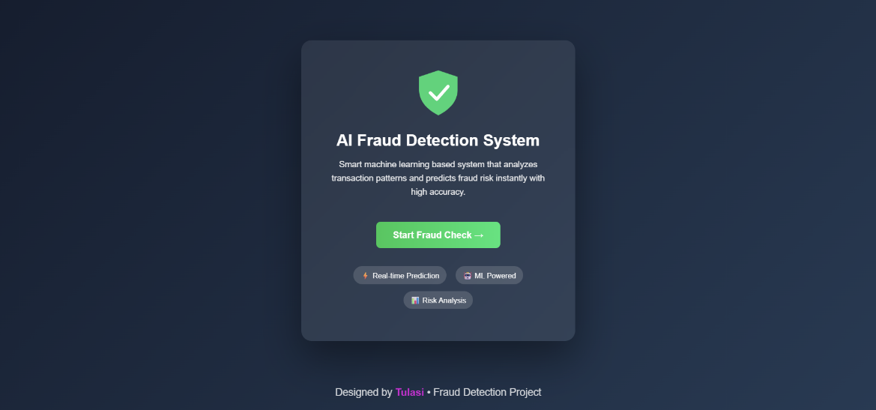
Now when you click on Fraud check button from top right corner you will get redirected to predict.html
Lets look how our predict.html file looks like:
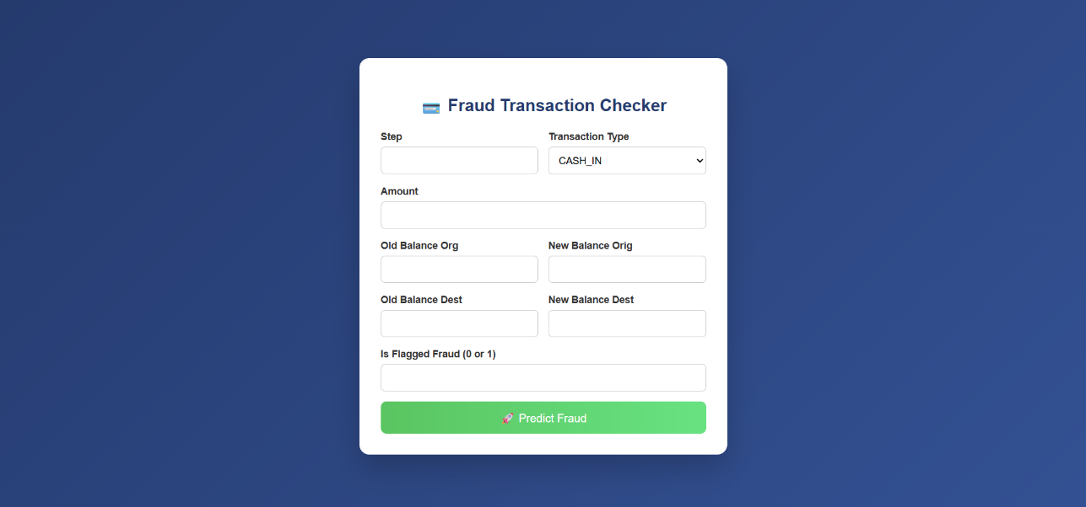
Now when you click on predict Fraud button you will get the prediction of the Fraud trasacation details
Lets look how our file looks like:
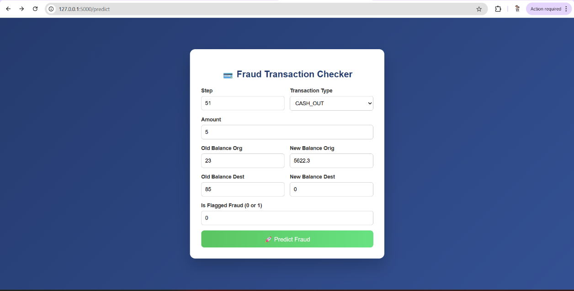
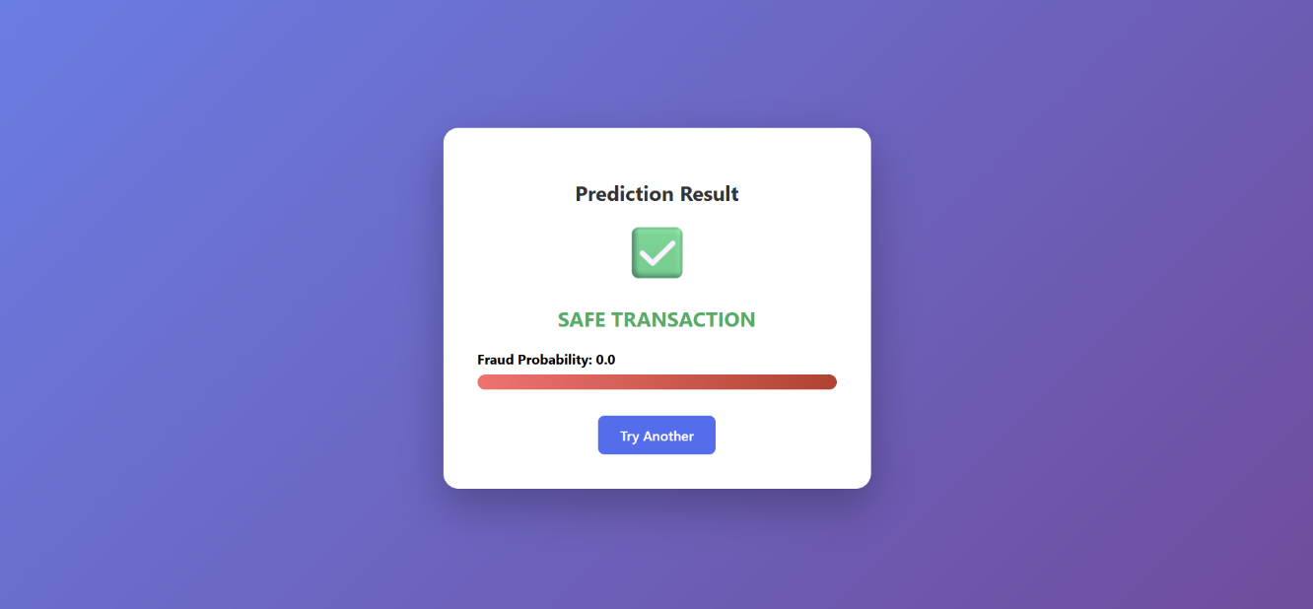

Activity 2: Build Python code:
Import the libraries
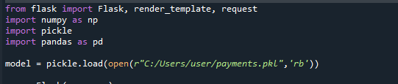
Load the saved model. Importing the flask module in the project is mandatory. An object of Flask class is our WSGI application. Flask constructor takes the name of the current module (__name__) as argument.
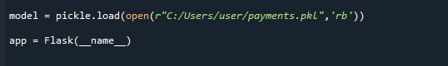
Render HTML page:
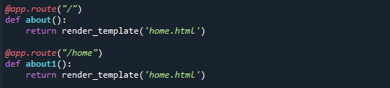
Here we will be using a declared constructor to route to the HTML page which we have created earlier.

In the above example, ‘/’ URL is bound with the home.html function. Hence, when the home page of the web server is opened in the browser, the html page will be rendered. Whenever you enter the values from the html page the values can be retrieved using POST Method.
Retrieves the value from UI:
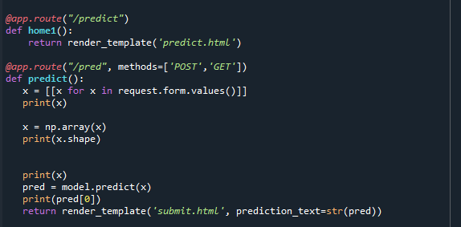
Here we are routing our app to predict() function. This function retrieves all the values from the HTML page using Post request. That is stored in an array. This array is passed to the model.predict() function. This function returns the prediction. And this prediction value will be rendered to the text that we have mentioned in the submit.html page earlier.
Main Function:
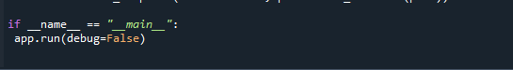

Activity 3: Run the application
• Open VS Code from the start menu.
• Click on File → Open Folder and select the folder where your python script is located.
• Click on Terminal → New Terminal.
• Now type “python app.py” command in the terminal.
• Navigate to the localhost where you can view your web page (http://127.0.0.1:5000/).
• Click on the predict button from the top right corner, enter the inputs, click on the submit button, and see the result/prediction on the web.
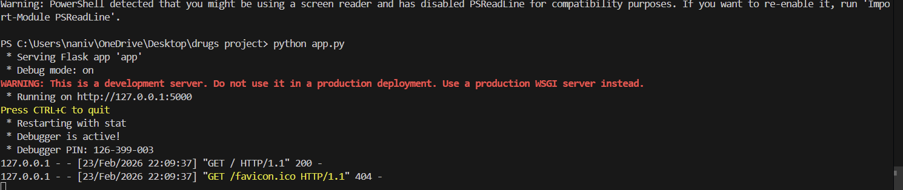



Conclusion:
Machine Learning techniques help in predicting fraudulent online transactions effectively using historical transaction data and user behavior patterns. This prediction helps in preventing financial fraud, reducing monetary losses, and improving the security of online payment systems. The system enhances trust, ensures safer digital transactions, and supports businesses in maintaining secure financial operations.

